Name: ____________________ Period: ____ Date: _____________

Staircases

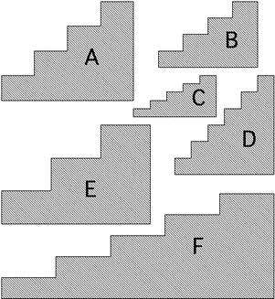 | - Without measuring the staircases, put them in order of "steepness," starting with the shape with the least “steepness.”
- Explain how you came up with your ranking of “steepness” in #1. Because you were asked NOT to measure, what “tools” or strategies did you use to make your decision?

- Now discuss your ranking in #1 with another classmate. Are you going to change your ranking? If so, please indicate your new ranking.

- No, I’m sticking with my original ranking.
- I’m changing my ranking to this…

- Now discuss your ranking in #3 with a different classmate. Are you going to change your ranking? If so, please indicate your new ranking.

- No, I’m sticking with my original ranking.
- I’m changing my ranking to this…

- You may now measure the staircases with whatever tool(s) you need. Use the space below to keep track of your measurements, calculations, and notes.

