**Pre-Calculus 11: Radical Equations Row Game**

Student A solves the problems in the left hand column, while Student B solves the problems in the right hand column. As you finish each problem, check your answer with your partner. The answers should be the same! If they are not, work together to find your mistake.

| **Student A** | **Student B** |
| --- | --- |
|  |  |
|  |  |
|  |  |
|  |  |
|  |  |
|  |  |

Solutions:

1)

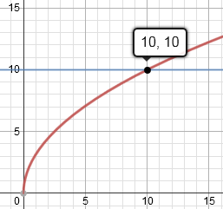 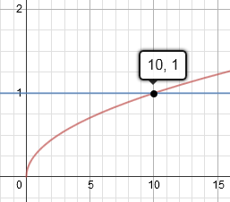

2)

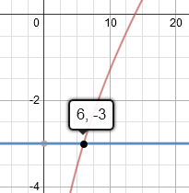 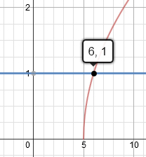

3)

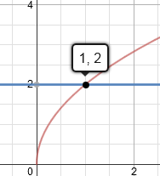 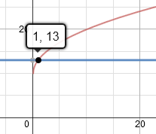

4)

