Pre-Calculus 11 - Sequences and Series Review
Name: __________________
Date: _________________
Name: __________
Date: __________
Block: __________

Question 1 – Going across and going down are different number sequences. Fill in the empty boxes so that each sequence has a pattern.
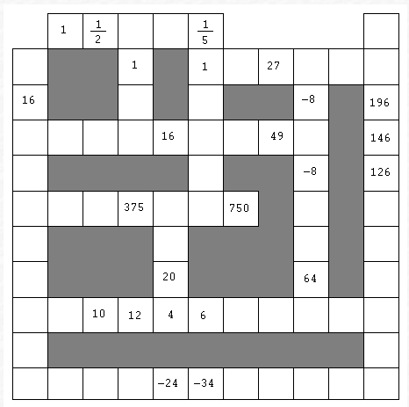
Question 2 – Complete the table below
First 5 Terms | arithmetic (d = ?)  geometric (r = ?)  neither | $$t_{1}$$ | $$t_{11}$$ | General Term $t_{n}$
-1, 4, 9, ____, ____
$\frac{1}{3}, \frac{1}{6}, \frac{1}{12}$, ____, ____
 | geometric $r=\frac{1}{5}$ | 15
$1,\frac{1}{2}, \frac{1}{3}, \frac{1}{4}$, ____
 |  |  |  | $$t_{n}=\frac{1}{3^{n-2}}$$
 | arithmetic d = 1 | -5 | 5
Question 3 - Fill in the empty boxes with positive numbers so that each row and column forms a geometric sequence. Each change of direction is a different sequence.
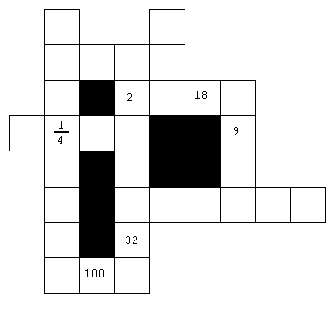

*** Solutions ***
Problems from Mathematics Teacher January 1989. Problem #2 is also on p45 #26 of textbook.
